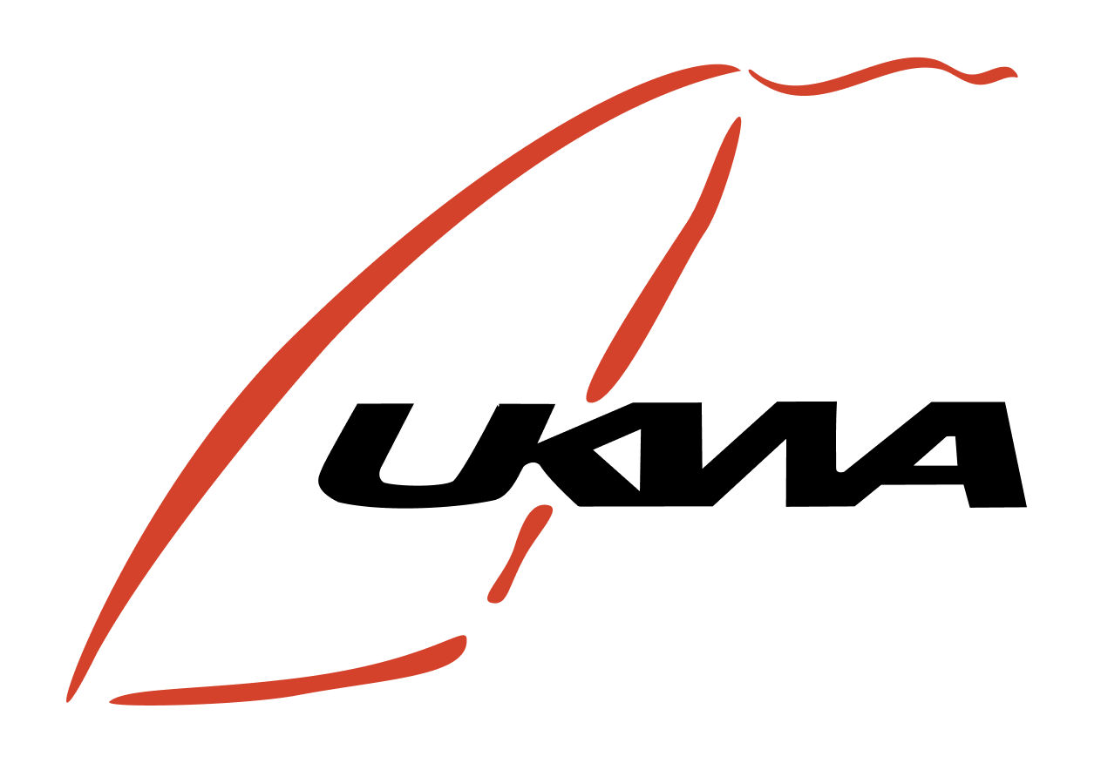

**Notice of Race (NOR) for the United Kingdom Windsports Association (UKWA), British Speed Championships - held at Weymouth Speed Week (WSW) 2024**

**1. EVENT**

1.1 Weymouth Speed Week will be held from Saturday 12th of October to the 18th of October 2024 at the WPNSA in Weymouth Dorset.

1.2 The event is the UKWA British National Speed Championship and held within the WSW event.

**2. ORGANISER**

2.1 The event will be organised by the Weymouth Speedweek committee. Racing and results will be run under specified conditions laid down by ISWC, IFCA, and ISAF with some adaptation for the UKWA British Championship.

**3. VENUE** The event will be held at the WPNSA, Osprey Quay, Portland, Dorset, DT5 1SA  
T: 01305 866000

**4. RULES**

4.1.1 The ISAF Racing Rules of Sailing (RRS);  
4.1.2 The ISWC General Rules with some adaptation for the UKWA British Championship.  
4.1.3 This Notice of Race ("NoR") and the Sailing Instructions (SIs);  
4.1.4 Alterations to the SIs must be approved by the Race Committee;

**UKWA RESULTS**

1.1 Timing will be available each day starting at 10.00, these times are subject to change at the discretion of the race officer. Timing will be taken from GPS units supplied by the organisers and the tracks analysed using GPS Results Pro Software.

1.2 For the UKWA Championship there is a break in the middle of the day at the discretion of the race officer, meaning that if the conditions allow there will be a maximum of 2 UKWA rounds per day.

**Windsurfing**

Windsurfing rounds will count towards the UKWA windsurfing rankings, if the following criteria are met.

1.1. There are at least 4 UKWA windsurfers who finish the round, referred to as finishers in 2.1 and 2.3.

2.1. Circa 25% of the finishers have a 2-run average of 28 knots or higher. The % calculation is detailed in 5.1.

2.2. Should the criteria for 2.1 be missed by a narrow margin (as described in 5.2), then 2.3 will be considered.

2.3. Circa 50% of the finishers have a 2-run average of 26 knots. The % calculation is detailed in 5.1.

3.1. A minimum of one completed UKWA round is required to ratify the event.

**Wingfoiling**

4.1. The windsurfing criteria for 1.1 - 3.1 will be used for the wingfoiling rankings, but with slightly lower speeds.

4.2. The wingfoiling rankings will use 25 knots and 23 knots as the criteria for 2.1 and 2.3 respectively.

**Percentages**

5.1. The criteria for 2.1 and 2.3 refer to percentages, but the actual calculation will be based upon floor division.

*Floor division (//) is a type of division that rounds down to the nearest integer less than or equal to the division result.*

The use of floor division ensures a greater number of fair counting rounds, instead of a strict 25% and 50%.

circa 25%... 20 finishers // 4 = 5 and 23 finishers // 4 = 5

circa 50%... 20 finishers // 2 = 10 and 23 finishers // 2 = 11

**Narrow Margins**

5.2. The criteria for 2.3 will only apply when 2.1 is missed due to one competitor, and by no more than half a knot.

**SCORING**

5.3 The low points scoring system shall apply. In the event of a tie on points the fastest speed is used.  
5.4 Discards will be based on the ISWC rulebook. 1-3 rounds = 0 discards, 4-6 rounds = 1 discard, 7-10 rounds = 2 discards, 11-14 rounds = 3 discards.

**5. ELIGIBILITY & DISCIPLINE**

5.5 A minimum of 1 round is required for a valid event result.  
5.6 Competitors shall possess valid third-party liability insurance.  
5.7 Competitors shall be entrants in Weymouth Speedweek and have paid their entry fee. Failure to do so will result in their results being withdrawn. 5.8 All competitors competing in the UKWA British Speed Championship need to be members of the UKWA.

**6. CLASSES**

6.1.1 This event shall be a single discipline event.  
6.1.2 Entry is accepted as described in the ISWC Rules.  
6.1.3 All competitors shall race together.  
6.1.4 Only equipment that meets the requirements of No 7 is allowed.

**7. EQUIPMENT**

7.1 All competitors may bring their own equipment.  
7.2 Equipment is not restricted in the ISWC class.

**8. BUOYANCY**

8.1 If personal buoyancy is prescribed, each competitor & support boat crewmember shall wear, above the waist, a jacket, harness, or vest with a minimum buoyancy of 4kg uninflated, in fresh water. The buoyancy shall be tested with a ferrous metal weight of 4kg, which shall remain afloat for a minimum of 5 minutes.  
8.2 Weight jackets are allowed but must be neutrally buoyant. Random checks will be carried out and disqualification will result if riders do not comply with this rule.

**9. LIABILITY**

9.1 Competitors take part in all races at their own risk. The LOA, ISWC, IFCA, UKWA, IWA, ISAF or any of their officials or representatives or the sponsors or their officials or representatives are not responsible, under any circumstances, for any damage, loss or injury either ashore or on the water either to persons or equipment, which may result from participation in this event.

**10. COURSES**

10.1 Courses shall be as described in by the Race Officer (RO) each day as part of the SI during the skippers meeting and will be placed on the WSW notice board.  
10.2 Flags will be used to denote the course start and finish on the course.

10.3 Zello is used where possible to communicate any changes to the sailing instructions during the day, particularly for those not based at WPNSA.

**11. INTERNATIONAL JURY**

11.1 An International Jury may be appointed. Their decisions will be final and cannot be appealed.

**12. EVENT PROGRAMME AND SAILING INSTRUCTIONS (SI)**

12.1 The Event programme and SI will be distributed at registration.

**13. COACHES**

13.1 Coaches are required to register in advance directly with the LOA.  
13.2 Coach boats may support competitors. If you propose to bring your own boat, please advise the local organisers in advance.  
13.3 Coaches shall wear buoyancy aids at all time.

**14. MEDALS AND PRIZES**

14.1 Trophies/Medals may be awarded to fastest in the Open and Female fleets.

14.2 Entry into the Female fleet will follow the World Sailing (WS) policy on eligibility and inclusion 2024.

**15. DRUG TESTING**

15.1 Competitors are reminded of the ISAF rules and regulations concerning the use of banned methods and substances. Drug testing may take place during the event.

**16. TELEVISION AND MEDIA**

16.1 In registering for the event, competitors automatically grant to the Organising Authority the right in perpetuity to make, use and show from time to time at their discretion, any motion pictures, still pictures and live, taped or filmed television and other reproduction of them, taken during the period of the event, for the said event as defined in the Notice of Race and Sailing Instructions in which the sailor participates without compensation.

**17. BIBS/VESTS & COMPETITORS SAIL BRANDING**

17.1 During racing, and free sailing competitors are be required by the organisers to wear bibs/vests carrying the event sponsors' branding; and carry the event sponsor's advertising on their sails.